STUDENT GUIDE FOR PREPARING TO TRAVEL TO SINGAPORE
PRE-DEPARTURE GUIDE

CONGRATULATIONS

Congratulations! Curtin University (Curtin) is delighted for you to participate in the Curtin Academy International Interdisciplinary Industry Study Tour Program — Singapore (the Program) under the Australian Government’s New Colombo Plan (NCP). NCP launched in 2014 and aims to lift knowledge in Australia of the Indo-Pacific by supporting Australian undergraduates to study and undertake internships in the region. The strategic objective of NCP is to strengthen Australia’s regional standing by building a diverse cohort of Australian alumni with deeper IndoPacific knowledge, capability, and connections.
The Program will run in Singapore for two weeks from 8th January 2023 to 22nd January 2023.The cost of the Program is anticipated to be approximately AUD$4,000 and will include return airfares, accommodation in Singapore, Host Program fees, in-country transport for program activities, social and cultural program activities, and some meals. It will not include additional spending money or any other expenses.

CONTENTS

Foreword | Page 4
Getting Ready | Page 5
Before You Pack | Page 7
Your Experience | Page 11
Singapore Information | Page 13
When You Arrive | Page 14
Resource Kit | Page 17

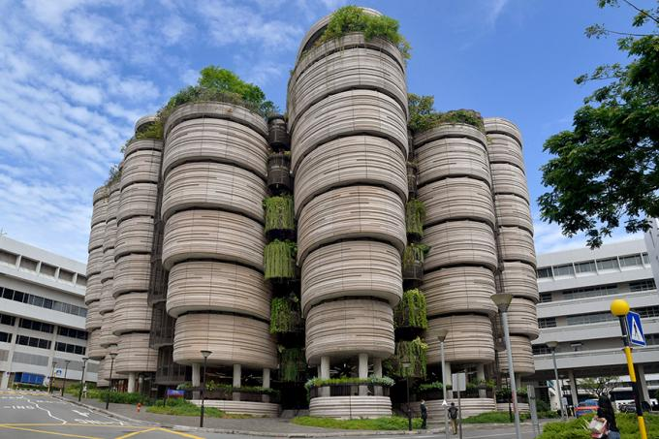

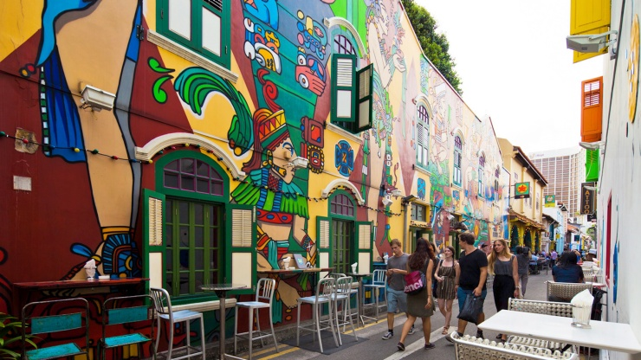

FOREWARD
Congratulations and Welcome to the 2022 Curtin Academy International Interdisciplinary Industry Study Tour Program
We are pleased that you will be joining part of this program, which is funded by the Department of Foreign Affairs and Trade as part of the New Colombo Plan initiative. As background, the Curtin Academy is a group of Curtin academics who are recognised experts in learning and teaching and whose focus for 2022 has been on enriching student experience.
This program is the first Curtin University mobility program to provide students with the important triple “I” experience of an international interdisciplinary industry focused research study.
The program will see 240 Curtin students and 20 staff from various Faculties (Health Science, Business and Law, Science and Engineering, and Humanities) travel to either Malaysia or Singapore in late 2022 or early 2023. As a student and part of this experience, you will be co-partnering in a consortium with educators and thought leaders from the Curtin Academy, Curtin Malaysia, Curtin Singapore and other industry experts.
In teams, you will engage in the Design Thinking process to explore a “hot-topic” that exists and develop a solution or prototype as the outcome of your investigation. Your team will present this suggested outcome to local industry as a pitch at the conference on the final day of the program. This pitch will form a major part of your assessment for the unit WORK2005.
There is an opportunity for some students to become Student Leaders within the program and for all students to become stewards of their own learning journey.
The program has been supported by an amazing team, throughout the year, including the Curtin Academy Executives and
- Mr Chris Leong,
- Ms Nikki Fairhurst,
- Ms Madeline Ayoub
- Dr Sherry Bawa Curtin Fellow
- Ms Christina Chong and the
- Curtin Academy Executive Officer Ms Stephanie Bruce
We hope that you look forward to this program and adventure and enjoy the learning experience that lies ahead!
Kind regards,
Associate Professor Rachel Sheffield
Chair, Curtin Academy and Program Lead
GETTING READY
There are important things you should arrange before you travel to Singapore. This section includes information, a packing guide, and pre-travel checklists to help you travel smoothly.
Research Singapore — Disclaimer
We have done our best to identify the main considerations for you against our program calendar; however, we may not have thought of everything.
The information in this booklet is correct at the time of preparation.
With international travel, laws, plans and other key aspects are always subject to change. You are intelligent adults, and you are stewards of your own learning journey. You should perform your own due diligence and conduct your own enquiries into where we are going, what risks are present and what you might need. Making these enquiries will prepare you for travel.
What to bring
The temperature in Singapore during January is Low 24°C/High31°C, with high relative humidity (84% on average). January falls within the rainy reason, and it is likely to rain several days of the trip. Therefore, it is important to pack clothes that fit accordingly. We ask you to bring formal attire and formal shoes for the dinner and to meet with industry partners during your travel. Furthermore, there will be some trekking activities, therefore we would also recommend bringing more than one pair of casual shoes. Please see the packing checklist on page 7 for further details on what to bring.
Medicine
If you need regular medicine for a medical condition (like diabetes, asthma, or eczema), you will need to bring this with you (you will need enough to last you at least 15 days while we travel), with a letter from your doctor and your medical history. Please note that you must tell us of any medical conditions you have ASAP (if you have not already). We need to ensure your safety and also, it can impact insurance (see page 11 for more information on insurance).
You should also bring medicine in case you get sick (like Panadol, nurofen, throat lozenges etc). When abroad, the same brands may not be present and sometimes this pre-thought about what medication you might need can be helpful in the event that you do get unwell.
Money
It is a good idea to bring approximately AUD $500 in cash for unexpected or immediate expenses as well as avoiding additional conversion charges when using your debit/credit card while abroad on every transaction. Do not expect to spend the entirety of the AUD $500; the recommended amount is to cover additional costs not associated with the NCP such as snacks, personal excursion activities, use of laundry facility, and shopping. The program is responsible for your flights, accommodation, emergencies, and some of your meals as outlined in the itinerary.
You can change Australian Dollars to foreign currency at the airport, shopping district currency exchanges or at any bank.
Can I bring food?
Singapore has rules about bringing food and other items like traditional medicine, plants, and organic material into and out of country to protect their environments. In many cases, these items will be confiscated at the airport, so you should try to avoid bringing them with you, and always declare what you do bring on your incoming Passenger Card. Singapore has specific requirements about entering goods and items. Please see here for further information about excepted and prohibited items.

BEFORE YOU PACK
Your Passport
You must travel on your Australian passport. This is what your airline ticket and other things are linked to. You are travelling as Australian citizens and representatives of Curtin.
Check your Australian passport’s expiry date and ensure it is valid for at least six months following our intended return date (i.e., six months from 10 December 2022).
We recommend you take a photo of your Australian Passport, so you have a digital copy in case it gets lost or stolen. Australian Passports can be stored in the safety deposit box in your room at our accommodation.
Visas and proof of program participation
Visitors holding an ordinary passport issued by Australia do not need a visa to travel to, and seek entry into, Singapore. Passports will just be stamped on arrival at the airport allowing you to stay for up to 90 days. However, be sure that you have proof that you will be attending this program to show Immigration on arrival at the airport i.e., Invitation letter from Curtin with itinerary.
As Singapore’s border measures and entry requirements will evolve as the global situation changes, please visit the MOH website (https://www.moh.gov.sg/covid-19) and ICA website (https://www.ica.gov.sg/enter-transit-depart) for the latest updates on travel and health control measures.
Payment
Your participation in this program is contingent on your signing and providing all relevant documentation, as well as paying the AUD $1000 student contribution. If you are unsure whether you have completed all of these, please contact CA-NCP@curtin.edu.au
Flights/Accommodation
Your flight will depart from Perth Airport on January 8th, 2023, at 11: 25 AM. You will arrive in Singapore at 16:45 PM the same day. You will be staying at the Fort Canning YWCA.
Timing your airport arrival
Arriving at the airport in time will ensure a smooth travel experience and as Curtin group booking. Please arrive at Perth International Airport by 8 30 AM on Sunday January 8th, 2023. You need to arrange your own transport to Perth airport.
Your health
Your medical history is important to consider when travelling. You must contact your doctor for a letter that includes the technical name of, and reason for, any prescription medicine you are bringing, or may need to buy while overseas. A documented medical history will ensure you get proper care in an emergency. You are responsible as well for receiving any necessary vaccinations prior to departure which is a personal expense.
Required Apps / Subscriptions
Smarttraveller
1. You must read the information about travel to Singapore on the Smarttraveller.gov.au website.
2. You must subscribe for Smarttraveller alerts for Singapore. This can be done via Smarttraveller.gov.au website.
International SOS App
As Curtin students, you must download and install the ‘International SOS’ app. This is a requirement of Curtin University.
WhatsApp
Download and install ‘WhatsApp’. We will create a group for everyone to easily communicate while on tour.
DFAT Go Global NCP Modules
You will need to complete the above before we depart. This information will be circulated separately.
Banking
It is important to notify your bank that you are about to travel and arrange to either access money while overseas or make charges in foreign currency. Otherwise, there might be a temporary block on your account which will limit your access to finances. Please note that eftpos facilities in Singapore may not be as present as they are in Australia. We recommend you bring some cash (AUD $500) to use to limit additional bank charges.
Mobile phones
You will need to be contactable while overseas to receive updates on our activities, to generally be safe and to communicate in the event of an emergency. We recommend you explore your options to use your phone while overseas. Ask your mobile phone carrier if your phone will work in Singapore. You might need to upgrade your plan to accommodate international calls or roaming data. You may also like to consider whether you will obtain a Singaporean SIM card. Curtin staff will advise more about SIM cards upon arrival.
Clothes
Please revise the packing checklist on pages 9 & 10 thoroughly to ensure you have packed the necessary items.

PRE-TRAVEL CHECKLISTS
Getting ready to travel
1. Australian Passport — valid for at least six months after 10 December 2022
2. Digital copies of your passport stored safely and left with family
3. Download and print international COVID certificate from Medicare (MyGov)
4. Complete Singapore arrival card between the 6 - 8th of January (prior to arrival)
https://www.ica.gov.sg/enter-transit-depart/entering-singapore/sg-arrival-card
5. Obtain medications and medical history / doctor’s letter (if required)
6. Obtain at least AUD$500 additional spending money
7. Register for Smarttraveller.gov.au updates for Singapore
8. Download and installed the ‘International SOS’ app
9. Download and installed ‘WhatsApp’
10. Receive your flight information (will be provided the week we travel)
11. Notify your bank that you will be travelling and potentially making transactions in Singapore
12. Check your mobile phone service availability and charges in Singapore
13. Store the emergency contacts on your personal devices
14. Curtin University Student ID
What to pack
The below is a guide to what you should pack. Again, think about anything else that you might require. We do not accept responsibility for any items that are lost or stolen.
Hand Luggage
· 1 x change of clothes (in case luggage is lost)
· 1 x light blanket or jacket (planes get cold!)
· Face masks – (you will likely need every day)
Clothing
· 2x semi-formal outfits (We will be visiting industry and attending conferences, so you need to be presentable and professional. For males, this means long pants rather than shorts)
· 1x semi-formal footwear
· 2-3x active wear outfits (We will be going on treks and otherwise exploring Singapore)
· 2x enclosed active footwear
· 3-4x casual outfits minimum
· 1x casual footwear
· 1x rain jacket / poncho
. 1x small beach towel
· 1x bathers / swimsuits
· 1x hat
· 1x sunglasses
Toiletries
· Toothpaste / toothbrush
· Hairbrush / hair ties
· Shampoo / conditioner
· Deodorant
· Face masks
· RAT tests
· Medication in case you get sick, i.e., Panadol / Nurofen, throat lozenges, cold n flu
· Sunscreen
· Bug repellent
· Nail clippers
· Band-Aids
· Small medical kit
Other
· Notebook / pens
· Laptop / laptop charger / Phone / phone charger
· Headphones (compatible with your personal devices)
· International travel adaptor (type G; see image below) / power board (optional)
· Reusable water bottle (the program centres on sustainability and you should limit use of plastic water bottles)
· Wet wipes / hand sanitiser / tissues
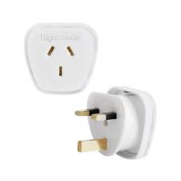
· A coffee keep cup (for the coffee addicts among us!)

YOUR EXPERIENCE
It is important that you know your rights and responsibilities. You have rights as a student which aim to protect you. You also have a number of responsibilities while travelling to Singapore. Below are a few things you may wish to consider that will protect you and those around you.
Taking care of your health and safety
You must always travel with others and never alone. You must always keep Curtin staff and your peers informed of your whereabouts. This is particularly important when you are not engaged in a formal program activity. It is important to let them know if you ever get lost while you are out or feel unsafe. If you are lost, the ISOS application can track your coordinates (press the track now button in the app). If you have any concerns regarding your experience in Singapore, please let Curtin staff know as soon as possible.
Your rights and responsibilities
It is your responsibility to adhere to the Student Conduct Guide and Student Charter provided by Curtin University and behave accordingly. It is also your responsibility to comply with all the requirements presented by staff members during your travel including (but not limited to) adhering to itinerary scheduling and completing tasks to the best of your abilities.
Curtin’s corporate travel insurance policy will apply provided that the conditions in Curtin’s Travel Procedures for Students are met.
Students are required to comply with all relevant country and local laws and regulations that apply in Australia, in the Host Location or at any other place where any part of a Program occurs. You must make yourself aware of and comply with the DFAT’s:
• Child Protection Policy 2017
• Preventing Sexual Exploitation, Abuse and Harassment (PSEAH) Policy 2019
• University Foreign Interference Taskforce – Guidelines to Counter Foreign Interference in the Australian University Sector 2019
This also includes understanding the reporting obligations under these policies. DFAT and Curtin has a zero-tolerance approach to child exploitation, child abuse and sexual exploitation, abuse and harassment.
Emergencies
If you are lost or feeling unsafe, or are concerned, you must notify a member of the Curtin staff immediately. The Curtin staff is there to help you 24 hours a day, 7 days a week including weekends. The staff contact information can be found in the Resource Kit Page 17.
Please save the following contacts on your personal mobile device.
In case of emergencies For all emergencies, life-threatening situations, or serious injuries:
Emergency Numbers in Singapore
- Police Emergencies 999
- Police Emergency SMS 71999
- Medical Emergency 995

SINGAPORE
Singapore has the third highest population density in the world, with a multicultural population. The country's people recognise the need to respect cultural identities of the major ethnic groups within the nation. ​Multiracialism is placed at high value in the constitution and goes on to shape national policies in education, housing, and politics. The country has many beautiful tourist sites, such as they're picture- perfect skyline, and their bustling metropolis is constantly evolving. There are bold and new experiences and adventures to be had by NCP participants when they visit the country for our program.
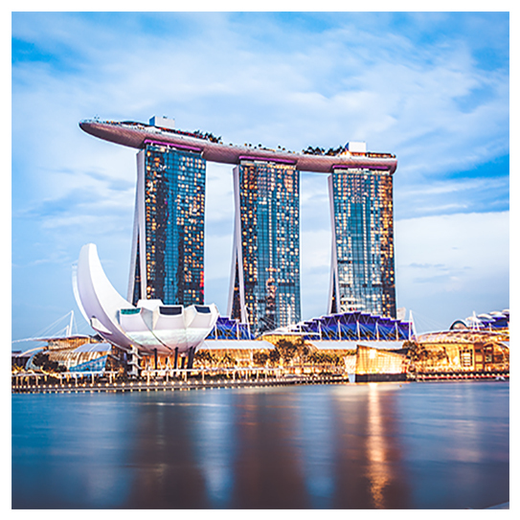
Cultural Sensitivity
Singapore is one of the most ethnically and culturally diverse countries I have ever visited. The Singaporean population comprises communities with for instance Malay, Chinese, Indian, Arabic, Jewish and Caucasian backgrounds.
To be present in such a unique melting pot of cultural diversity is highly rewarding yet can be confusing at first glance. It may take time to adapt to this fast-paced and highly dynamic environment, but it is highly advisable to try to learn as much as possible about the cultures, traditions, and behaviours of the various communities you encounter. This is very important, as Singapore prides itself on being home to people with heterogeneous backgrounds, which visitors should embrace and respect.
Singaporean greetings vary between the major ethnic groups. A handshake generally suffices as the appropriate greeting between two people. However, Malay or Indian Singaporeans may not wish to shake hands with the opposite gender.

AIRPORT ACTIVITIES
There is some layover time, so please use this time to exchange money and have a snack. At the airport, you can complete the Sustainable Development Goals (‘SDGs') Challenge Hub. A link to SDGs Challenge Hub allows you to explore the Sustainable Development Goals, particularly in the context of Singapore.
Pay attention to some of the SDGs that Singapore has so far achieved, as well as the SDGs that require further progress.
https://challenge.curtin.edu.au/dashboard
NCP SINGAPORE SDGs
Sign in using your Curtin student ID and password.
WHEN YOU ARRIVE
You will arrive in Singapore at 16:45 pm (Singapore time). You will be transported to the YWCA Fort Canning which will be your accommodation for the two-weeks in Singapore. YWCA Fort Canning is located beside Fort Canning Park, 275m from Plaza Singapura. It features a swimming pool and air-conditioned rooms with a cable TV. The Lodge is a 5-minute walk from the National Museum and 150 m from Dhoby Ghaut MRT Station. The Coffee House serves a variety of local and Western dishes. A la carte menu options are also available.
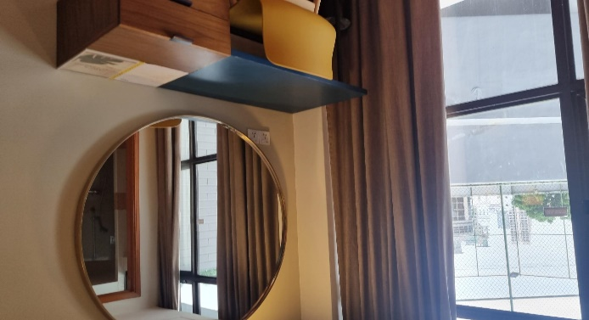
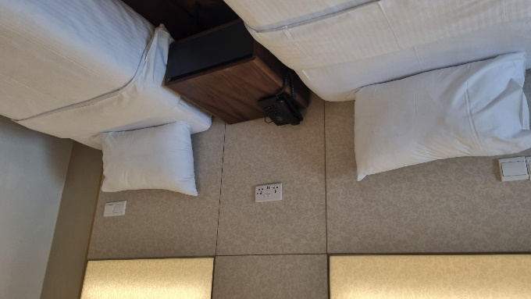

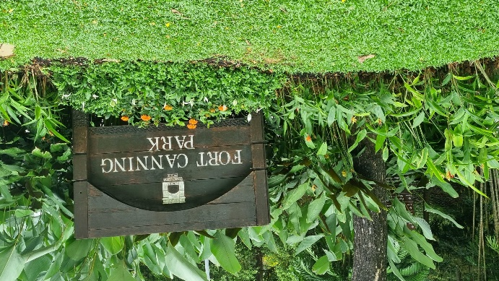

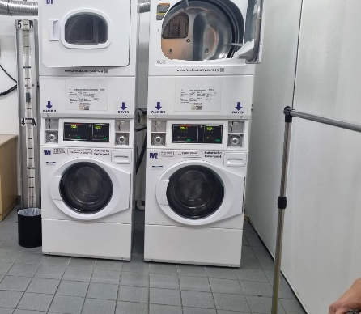
Laundry on site
The hotel provides an on-site laundry service. We recommend gathering your laundry alongside your roommates to reduce costs.

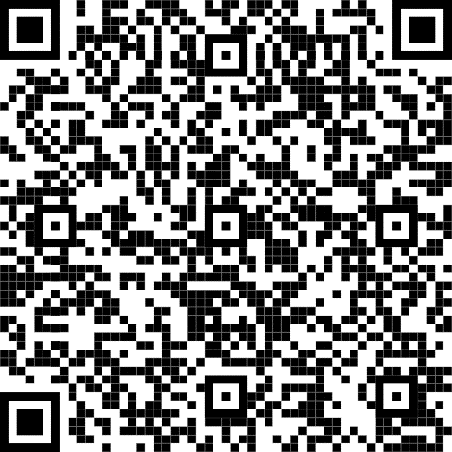
Where will you go?
SCAN ME
The itinerary is jam-packed with exciting and interesting cultural activities. Some of the top destinations include:
- Haw Pa Villa Gardens
- Singapore City Gallery
- National Design Centre
- GHY Media Studio
- Pulau Ubin Site Visit
- Gardens by the Bay
- Asian Civilisation Museum
& so much more!
Industry
You will be meeting with industries to cover the topics of homelessness, environmental wellbeing, and tourism.
Industry | Topics & Speakers
Urban Redevelopment Authority
Pulau Ubin Site Visit | National Parks  Adrian Loo: Climate action, Life below water, life on land  Asian Detours: Challenges of running an eco-tourism business
NUS Knowledge sharing symposium | Accessible and adequate housing to tackle homelessness by LKY School of Public Policy - Why Universities should steer climate action?  The challenge for ASEAN: To be digital and sustainable: Prof Simon Tay (Law) and Jessica Wau (Singapore institute of International Affairs)  Maximising value from waste by Prof Lawrence Loh (Centre of Governance, Institution and Organisation)  Placing ASEAN on stronger footing in a net zero future by A/Prof Simon Tay (SIIA)
Knowledge Sharing Round table and workshop, Sustainability focused event with representatives of NGOs based in Singapore | SICC – Victor Mills  Khaw Boon Wan, Former minister of transport  SingHealth - Dr Ng Kok Hoe & Dr Teo You Yenn – Social equality (SDG 1 & 10)

RESOURCE KIT
Meet the staff!
Rachel Sheffield
Dr Rachel Sheffield is an Associate Professor in the School of Education at Curtin University, Australia and is a passionate science educator and the Chair of the prestigious Curtin Academy which supports and celebrates excellent teaching. Dr Sheffield’s research interests include women in STEM through her STEMinist community. Research grants has seen her travel to India, Indonesia and Malaysia supporting pre-service teachers, teachers and primary students (steminists.weebly.com/). She is also interested in PBL and design thinking and is currently exploring environmental sustainability in education.
Mobile: +61 407 999 995
Email: Rachel.sheffield@curtin.edu.au
Stephanie Bruce
Ms Stephanie Bruce is a Sessional Academic within Curtin Law School and Editorial Consultant for several scholarly academic journals including the Australian Tax Review and the Curtin Law and Taxation Review. She has a keen interest in legal research / writing, corporate insolvency and dare she say it, tax. Stephanie is currently pursuing her Master of Laws at the Australian National University. She is also the Executive Assistant for the Curtin Academy and has been your main point of contact for Curtin Academy.
Mobile: +61 439 979 226
Email: Stephanie.bruce@curtin.edu.au
Chris Leong
Chris holds a Bachelor of Applied Science (Architectural Science) and a Master (Coursework) in Architecture from Curtin University, Australia. His area of interest and research focuses on the nexus between cognition and tactility, design thinking processees, digital mind mapping, and modelling of creative concepts. As a skilful designer and digital fabricator, he is regularly invited to design, develop and craft creative projects in both public and private sectors.
Mobile: +61 438 722 817
Email: Chris.leong@curtin.edu.au

Nicole Fairhurst
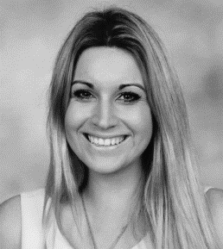
Miss Nikki Fairhurst has a Bachelor of Education (Primary) and a Master of Philosophy (Education) from Curtin University, Australia. She is a passionate educator, and through her school leadership relating to STEM education and inquiry learning models, was awarded her Level 3 Teacher status and the 2021 United Nations Associated of Australia WA Division’s (UNAAWA) Primary Teacher Award. Nikki has now commenced her PhD at Curtin University and is a sessional tutor for pre-service teachers.
Mobile: +61 433 613 168
Email: Nicole.fairhurst@curtin.edu.au

Michelle de Kok
Michelle has completed a Bachelor of Science (Multidisciplinary) and a Graduate diploma in Secondary Teaching (Science and Math). She is a Sessional Tutor and Professional Experience Supervisor of Pre-Service Teachers at Curtin University. Her interests lie in empowering girls in STEM, STEM education, PBL using Design thinking models, Inquiry teaching and digital technologies. She is currently completing her Masters. She co-authored a book chapter with Rachel Sheffield on Design thinking process in the Transformative STEAM Education for Sustainable Development book.
Email: michelle.dekok@curtin.edu.au

Lisa Tee
Associate Professor Lisa Tee is an inaugural Curtin Academy Fellow and Executive Member of Curtin Academy appointed in 2014 in recognition of her leadership and excellence in Higher Education. In her capacity as Director of Learning and Teaching (L&T) (2008 to 2015), Curtin Academy Fellow and Chair of Pharmaceutical Biology Subject Committee, Lisa actively contributes to strategic plans, building leadership capacity and excellence in L&T amongst colleagues at the school, faculty and university levels. Lisa chaired the School L&T Committee, represented the School on Faculty L&T matters through participation on relevant committees including Faculty T&L, Faculty Academic Board, Curtin Higher Education Research Committee, Curtin Academy Advisory Group, Working Party for MOOCS, Working Party for Digital Experience at Curtin and recently Working Party for Teaching Academics. Lisa created the MyCourseMap, an innovative visual interactive curriculum map to provide students with clear vision as they navigate through the complexity of their course. Lisa’s mission statement is 'Learning and Teaching with triple E: Energy, Enthusiasm and Empathy'.
Email: L.Tee@curtin.edu.au

Curtin Academy
Please follow the following link to find out more about Curtin Academy, the host and organiser of the program.
https://www.curtinacademy.com/

CA-I³SP Website
You can find a summary of the New Colombo Plan at the following link:
https://www.curtinacademy.com/newcolumboplan
Please use the link below to access the program’s website which includes a traveller’s portal on the connect page with further information about your travel with links to questions and answers boards, and itinerary guides available.
https://ca-i3sp.weebly.com/

Social Media Access
Instagram
Username: n_c_p_2022

Facebook
Curtin Academy NCP

QR Code
Please use the following QR Code to ask questions about the program, activities, and other information.

