STUDENT GUIDE FOR PREPARING TO TRAVEL TO MIRI MALAYSIA
PRE-DEPARTURE GUIDE

CONGRATULATIONS

Congratulations! Curtin University (Curtin) is delighted for you to participate in the Curtin Academy International Interdisciplinary Industry Study Tour Program — Miri, Malaysia (Round 1) (the Program) under the Australian Government’s New Colombo Plan (NCP). NCP launched in 2014 and aims to lift knowledge in Australia of the Indo-Pacific by supporting Australian undergraduates to study and undertake internships in the region. The strategic objective of NCP is to strengthen Australia’s regional standing by building a diverse cohort of Australian alumni with deeper IndoPacific knowledge, capability, and connections.
The Program will run in Miri, Malaysia for two weeks from 6 JANURARY 2023 to 20 JANURARY 2023.The cost of the Program is anticipated to be approximately AUD$3,100 and will include return airfares, accommodation in Miri, Host Program fees, in-country transport for program activities, social and cultural program activities, and some meals. It will not include additional spending money or any other expenses.

@ Copyright & Disclaimer
CONTENTS

Foreword | Page 4
Getting Ready | Page 5
Before You Pack | Page 6
Your Experience | Page 11
Miri Malaysia | Page 13
Airport Activities | Page 14
When You Arrive | Page 14
Resource Kit | Page 16

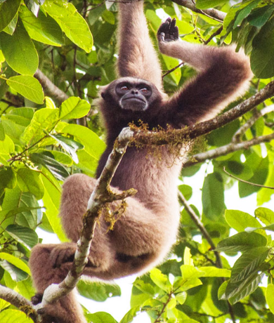

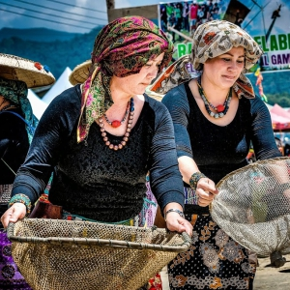

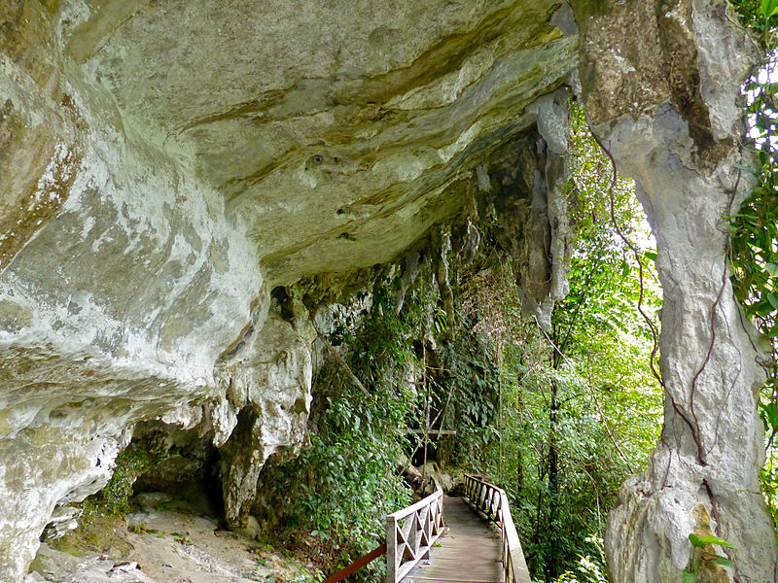

FOREWARD
Congratulations and Welcome to the 2022 Curtin Academy International Interdisciplinary Industry Study Tour Program
We are pleased that you will be joining part of this program, which is funded by the Department of Foreign Affairs and Trade as part of the New Colombo Plan initiative. As background, the Curtin Academy is a group of Curtin academics who are recognised experts in learning and teaching and whose focus for 2022 has been on enriching student experience.
This program is the first Curtin University mobility program to provide students with the important triple “I” experience of an international interdisciplinary industry focused research study.
The program will see 240 Curtin students and 20 staff from various Faculties (Health Science, Business and Law, Science and Engineering, and Humanities) travel to either Malaysia or Singapore in late 2022 or early 2023. As a student and part of this experience, you will be co-partnering in a consortium with educators and thought leaders from the Curtin Academy, Curtin Malaysia, Curtin Singapore and other industry experts.
In teams, you will engage in the Design Thinking process to explore a “hot-topic” that exists and develop a solution or prototype as the outcome of your investigation into that hot-topic. Your team will present this suggested outcome to local industry as a pitch at the conference on the final day of the program. This pitch will form a major part of your assessment for the unit WORK2005.
There is an opportunity for some students to become Student Leaders within the program and for all students to become stewards of their own learning journey.
The program has been supported by an amazing team, throughout the year, including the Curtin Academy Executives and
- Mr Chris Leong,
- Ms Nikki Fairhurst,
- Ms Madeline Ayoub
- Dr Sherry Bawa Curtin Fellow (Summit)
- Ms Christina Chong and Ms Jo Castelli and the
- Curtin Academy Executive Officer Ms Stephanie Bruce
We hope that you look forward to this program and adventure, and enjoy the learning experience that lies ahead!
Kind regards,
Associate Professor Rachel Sheffield
Chair, Curtin Academy and Program Lead

GETTING READY
There are important things you should arrange before you travel to Miri Malaysia. This section includes information, a packing guide, and two of pre-travel checklists to help you travel smoothly.
Research Miri — Disclaimer
We have done our best to identify the main considerations for you against our program calendar, however we may not have thought of everything.
The information in this booklet is correct at the time of preparation.
With international travel, laws, plans and other things, things do change. You are intelligent adults, and you are stewards of your own learning journey. You should perform your own due diligence and conduct your own enquiries into where we are going, what risks are present and what you might need. Making these enquiries will prepare you for travel.
What to bring
The temperature in Miri during January is Low 23°C/High 30°C, with high relative humidity. January is part of the rainy season, and it is likely to rain most days. Therefore, it is important to pack clothes that fit accordingly. We ask you to bring formal attire and formal shoes for the dinner and to meet with industry partners during your travel. Furthermore, there will be some trekking activities, therefore we would also recommend bringing more than one pair of casual shoes. Please see page 9 & 10 for a complete checklist on what to bring.
Medicine
If you need regular medicine for a medical condition (like diabetes, asthma, or eczema), you will need to bring this with you (you will need enough to last you at least 15 days while we travel), with a letter from your doctor and your medical history. Please note that you must tell us of any medical conditions you have ASAP and we may require specifics of when you take it and what is actually is (if you have not already). We need to ensure your safety and also, it can impact insurance (see page 11 for more information on insurance).
You should also bring medicine in case you get sick (like Panadol, nurofen, throat lozenges etc). When abroad, the same brands may not be present and sometimes this pre-thought about what medication you might need can be helpful in the event that you do get unwell.
Money
It is a good idea to bring about AUD $500 in cash for unexpected or immediate expenses as well as avoiding additional conversion charges when using your debit/credit card while abroad on every transaction. Do not expect to spend the entirety of the AUD $500; the recommended amount is to cover additional costs not directly associated with the NCP such as snacks, personal excursion activities, use of laundry facility, and shopping. The program is responsible for your flights, accommodation, emergencies, and some of your meals as outlined in the itinerary.
You can change foreign currency at the airport, shopping district currency exchanges or at any bank. It would be preferred that you change $100-200 Australian at the KL airport prior to arriving in Miri. There are money changers in our building in the shopping centre on 1st and 2nd floor and across the bridge in the other shopping centre.
Can I bring food?
Malaysia has rules about bringing food and other items like traditional medicine, plants, and organic material into and out of country to protect their environments. In many cases, these items will be confiscated at the airport, so you should try to avoid bringing them with you, and always declare what you do bring on your incoming Passenger Card. Malaysia has specific requirements about entering goods and items. Please see here for further information about excepted and prohibited items.

There is a hyper market downstairs in the shopping centre on B1 and therefore you can buy things you want. If you can not live without your lollies or snacks from home, you many want to bring them.

BEFORE YOU PACK
Australian Passport
You must travel on your Australian passport. This is what your airline ticket and other things are linked to. You are travelling as Australian citizens and representatives of Curtin.
Check your Australian passport’s expiry date and ensure it is valid for at least six months following our intended return date (i.e., six months from 1st January 2023).
We recommend you take a photo of your Australian Passport, so you have a digital copy in case it gets lost or stolen. Australian Passports can be stored in the safety deposit box in your room at our accommodation.
Visas and proof of program participation
Australian Passport holders will receive a visa-on-arrival into Malaysia. Your Passport will be stamped when we land in Malaysia at the airport. This allows you to stay for up to 90 days.
You will need to show Malaysian immigration proof that you are attending this program on arrival at the airport. You will need to bring the Offer Letter from Curtin with any itinerary (such as this document).
Payment
Your participation in this program is contingent on your signing and providing all relevant documentation as well as paying the AUD $100 student contribution. If you are unsure whether you have completed all these, please contact CA-NCP@curtin.edu.au
Flights / Accommodation
Flights have been booked via Malaysia Airlines and travel dates are Tuesday 6th January 2023 (flight departs at 2:25am), arriving back in Perth on Saturday 21st January 2023 at 1:25 am. You will receive your plane tickets the week that we leave. As mentioned previously, flights cannot be changed. We have secured apartments at Imperial Hotel Miri. We recommend you research the apartment hotel, its amenities and what is nearby. You will be staying in apartments with 2–3 other students.
Timing your airport arrival
Arriving at the airport in time will ensure a smooth travel experience and as Curtin group booking. Please arrive at Perth International Airport by 11 30 pm Monday 5th January 2023. You need to arrange your own transport to Perth airport.

Your health
Your medical history is important to consider when travelling. You must consult your doctor for a letter that includes the technical name of, and reason for, any medicine you are planning to bring or may need to buy while overseas. A documented medical history will ensure you get proper care in an emergency. You are responsible as well for receiving any necessary vaccinations prior to departure which is a personal expense.
Required Apps / Subscriptions
Smarttraveller
1. You must read the information about travel to Malaysia on the Smarttraveller.gov.au website.
2. You must subscribe for Smarttraveller alerts for Malaysia. This can be done via Smarttraveller.gov.au website.
International SOS App
3. As Curtin students, you must download and install the ‘International SOS’ app. This is a requirement of Curtin University.
MySejahtera App
4. You must download and install the ‘MySejahtera’ app which Malaysia uses to indicate COVID-19 risk status, which may be checked when entering premises, such as shopping malls.
WhatsApp
5. Download and install ‘WhatsApp’. We will create a group for everyone to easily communicate while on tour. This is our major communication and has worked very effectively in Miri 1
DFAT Go Global NCP Modules
You will need to complete the above before we depart. This information will be circulated separately.

Banking
It is important to notify your bank that you are about to travel and arrange to either access money while overseas or make charges in foreign currency. Otherwise, there might be a temporary block on your account which will limit your access to finances. Please note that EFTPOS facilities in Malaysia may not be as present as they are in Australia. We again recommend you bring AUD $500 cash to use, and to limit additional bank charges.
Mobile phones
You will need to be contactable while overseas to receive updates on our activities, to generally be safe and to communicate in the event of an emergency. We recommend you explore your options to use your phone while overseas. Ask your mobile phone carrier if your phone will work in Miri Malaysia. You might need to upgrade your plan to accommodate international calls or roaming data. You may also like to consider whether you will obtain a Malaysian SIM card. Curtin staff will advise more about SIM cards upon arrival.
Clothes
Please revise the packing checklist thoroughly on Page 8 to ensure you have packed the necessary items.
PRE-TRAVEL CHECKLISTS
Getting ready to travel
1. Australian Passport — valid for at least six months after 10 December 2022
2. Digital copies of your passport stored safely and left with family
3. Offer Letter from Curtin with itinerary (such as this document)
4. Obtained medications and medical history / doctor’s letter (if required)
5. Obtained at least AUD$500 additional spending money 6. Registered for Smarttraveller.gov.au updates for Malaysia 7. Downloaded and installed the ‘International SOS’ app
8. Downloaded and installed the ‘MySejahtera’ app
9. Downloaded and installed ‘WhatsApp’
10. Received your flight information (will be provided the week we travel)
11. Notified your bank that you will be travelling and potentially making transactions in Malaysia
12. Checked your mobile phone service availability and charges in Malaysia
13. Stored the emergency contacts on your personal devices
14. Curtin University Student ID
What to pack
The below is a guide to what you should pack. Again, think about anything else that you might require. We do not accept responsibility for any items that are lost or stolen.
Hand Luggage
· 1 x change of clothes (in case luggage is lost)
· 1 x light blanket or jacket (planes get cold!)
· Face mask
Clothing
· 2 x semi-formal outfits (We will be attending conferences, so you need to be presentable. Also for males, formal pants is preferred)
· 1 x semi-formal footwear
· 2-3 x active wear outfits (We will be going on treks and otherwise exploring Miri)
· 1-2 x enclosed active footwear
· 3-4 x casual outfits
· 1 x casual footwear
· 1 x rain jacket / poncho
. Small beach towel
· Bathers/swimsuits (one-piece swimsuits with appropriate swimming shorts for females)
· 1 x hat
· 1 x sunglasses
Toiletries
· Toothpaste and toothbrush
· Hairbrush and hair ties
· Shampoo and conditioner
· Deodorant
· Face masks
· RAT tests
· Medication in case you get sick, i.e. Panadol / Nurofen, throat lozenges, cold n flu
· Sunscreen
· Bug repellent
· Nail clippers
· Band-Aids
· Small medical kit
Other
· Notebook / pens
· Laptop / laptop charger
· Phone / phone charger
· Headphones (compatible with your personal devices)
· International travel adaptor (type G; see image below)
· Reusable water bottle (the program centres on sustainability and you should limit use of plastic water bottles)
· A coffee keep cup (for the coffee addicts among us!)
- Torch to visit the caves

YOUR EXPERIENCE
It is important that you know your rights and responsibilities. You have rights as a student which aim to protect you. You also have a number of responsibilities while travelling to Malaysia. Below are a few things you may wish to consider that will protect you and those around you.
Taking care of your health and safety
You must always travel with others and never alone. You must always keep Curtin staff and your peers informed of your whereabouts. This is particularly important when you are not engaged in a formal program activity. It is important to let them know if you ever get lost while you are out or feel unsafe. If you are lost, the ISOS application can track your coordinates (press the track now button in the app). If you have any concerns regarding your experience in Miri Malaysia, please let Curtin staff know as soon as possible.
Your rights and responsibilities
It is your responsibility to adhere to the Student Conduct Guide and Student Charter provided by Curtin University and behave accordingly. It is also your responsibility to comply with all the requirements presented by staff members during your travel including (but not limited to) adhering to itinerary scheduling and completing tasks to the best of your abilities.
Curtin’s corporate travel insurance policy will apply provided that the conditions in Curtin’s Travel Procedures for Students are met.
Students are required to comply with all relevant country and local laws and regulations that apply in Australia, in the Host Location or at any other place where any part of a Program occurs. You must make yourself aware of and comply with the DFAT’s:
• Child Protection Policy 2017
• Preventing Sexual Exploitation, Abuse and Harassment (PSEAH) Policy 2019
• University Foreign Interference Taskforce – Guidelines to Counter Foreign Interference in the Australian University Sector 2019
This also includes understanding the reporting obligations under these policies. DFAT and Curtin has a zero-tolerance approach to child exploitation, child abuse and sexual exploitation, abuse and harassment.
Emergencies
If you are lost or feeling unsafe, or are concerned, you must notify a member of the Curtin staff immediately. The Curtin staff is there to help you 24 hours a day, 7 days a week including weekends. The staff contact information can be found in the Resource Kit page 14.
Please save the following contact information for emergencies on your personal mobile device.
For all emergencies, life-threatening situations, or serious injuries:
Emergency call in Malaysia: 085-433730
Fire Station: 994
Police in Miri Malaysia: 085-433222
If you are involved in an emergency, you must always notify the Curtin staff.

ABOUT MIRI, MALAYSIA
The program will be based in and around the town of Miri which is the second largest city in Sarawak. It has a population of over 300,000 inhabitants.
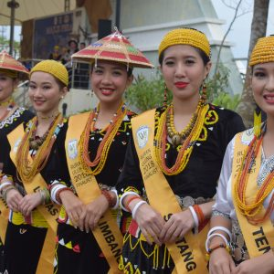
Take this chance to explore the spectacular rainforests and alpine meadows of Miri. The National Parks have their own distinct attractions: Gunung Mulu is teeming with caves and limestone formations; Niah was the discovery site of prehistoric human remains; Lambir Hills features stunning waterfalls and wildlife; and Loagan Bunut is ideal for hiking and birdwatching. Visiting this country for our program exposes you to the diverse culture and people of the country, as well as the breath-taking views.
Cultural Sensitivity
Malaysia is a multi-cultural society. The main ethnic groups are the native Malays as well as large populations of Chinese, and Indians. When visiting the country it is clear that the ethnicities retain their religions, customs and way of life. The most important festivals of each group are public holidays.
As members of such a multicultural society, Malaysians are generally very attentive towards how they respectfully interact with people of all backgrounds. There are cultural norms and taboos that inform what people generally believe to be appropriate and inappropriate behaviour. This is related to the Malay concept of ‘budi’ by which politeness and respect are considered essential to human interaction. The word does not have a direct English equivalent but can be generally understood to describe attributes such as one’s wisdom, virtue, etiquette and morality. In this way, one can see that Malaysian politeness and etiquette have a strong ethical basis.
Greetings in a social context will depend upon the ethnicity of the person you are meeting. In general, most Malays are aware of Western ways, so the handshake is normal. There may be slight differences though and a few things to bear in mind include:
Malay women may not shake hands with men. Women can of course shake hands with women. Men may also not shake hands with women and may bow instead while placing their hand on their heart.

AIRPORT ACTIVITIES
There is some layover time at Kuala Lumpur (KL), so please use this time to exchange money and have a snack. At the airport in KL, you can complete the Sustainable Development Goals (SDGs) Challenge Hub. A link to SDGs Challenge Hub allows you to explore the Sustainable Development Goals, particularly in the context of Malaysia.
Pay attention to some of the SDGs that Malaysia has so far achieved, as well as the SDGs that require further progress. https://challenge.curtin.edu.au/dashboard/#hub/100132
Sign in using your Curtin student ID and password.
WHEN YOU ARRIVE
You will arrive at 16:20 pm (Malaysian time) to Miri, Malaysia. Once we arrive at the accommodation at Imperial Hotel, there will be a group check in alongside an orientation for money exchange, emergency contacts, and an on-site induction.
Imperial Hotel Miri is set next to Permaisuri Imperial City Mall in Miri. All rooms are air-conditioned and free WiFi is accessible throughout. Imperial Restaurant opens for lunch and dinner, which specializes in Asian, local and western dishes. Coffee and light meals can be enjoyed at Permaisuri Coffee House.
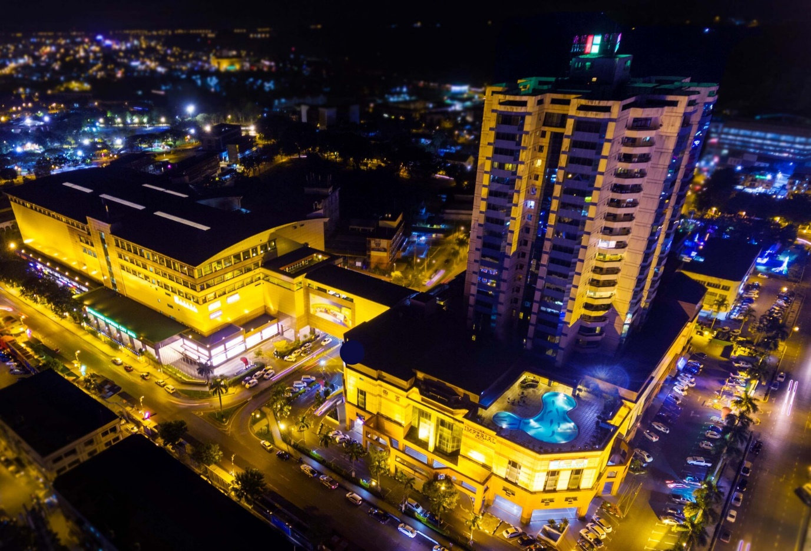
Nearby Locations | Nearby Restaurants
Pelita Park | Starbucks
Hornbill Nature Reserve | Ha Shi Sushi
Miri City Fan Park | KFC
Selera | Madli’s

Laundry on site
The hotel provides an on-site laundry service. We do, however, recommend gathering your laundry alongside your roommates to reduce costs.

Where will you go?
The itinerary for Miri, Malaysia (scan the QR Code for detailed map) is composed of cultural activities, conferences, and leisure time.
A summary of places you will visit include:
- Muhibbah Tamu Markets
- Heritage Centre
- Temple visits
- Waterfront
- Mega Mall
- Boat Club
- Niah Caves
- Miri City Council
- Miri Port

RESOURCE KIT
Meet the staff!
Rekha Koul
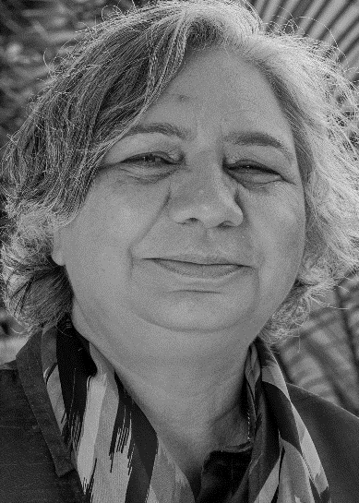
Dr Rekha Koul is an Associate Professor and Discipline Lead at STEM Research Group, School of Education, Curtin University, Australia. Dr Koul has over three decades of teaching and research experience. She sits on various advisory and editorial boards. Her expertise lies in the development, refinement and validation of questionnaires; investigations of the effects of classroom environments on student outcomes; evaluation of educational programs; teacher-action research aimed at improving their environments and evaluation of curriculum. Her publication record includes two books authored, seven books edited, eight book chapters and many journal articles published in peer-reviewed journals. She has won research grants worth 1.2 million dollars, has delivered invited keynote addresses in various countries and also conducts teacher professional learning workshops. Rekha convenes the International Conference on Science, Mathematics and Technology Education (icSTEM), a biannual conference in different parts of the world and has established a Learning Environment Research Centre at Universitas Negeri Jakarta, Indonesia.
Email: Rekha.koul@curtin.edu.au

Christina Chong
Christina recently graduated in early 2022 with a Bachelor of Commerce in Event Management at Curtin University. She is now the Student Experience Coordinator for Science and Engineering in the Student Engagement team, but has previously worked in other areas and teams around the University. She has participated in the Stanford Design Your Life intensive workshop that was conducted here at Curtin in 2018 when the Stanford Life Design Lab Lecturers came to Curtin for a week, and has since facilitated many workshops alongside the Life Design Lab team and Curtin Business School.
Outside of work she is obsessed with her dog, a huge foodie and enjoys watching the soccer and cricket.
Email: christina.chong@curtin.edu.au

Joanne Castelli
Dr Joanne Castelli is an Educational Designer in the Faculty of Science and Engineering at Curtin. Her role includes supporting academic staff with teaching strategies and resources, the provision of professional development opportunities and the development of innovative approaches to teaching.
Joanne has a PhD in Molecular Biology and Biochemistry and started her career in laboratory research. Her teaching roles have covered a range of topics from biochemistry, molecular biology, microbiology and science communication to coordination of a postgraduate Foundations of Tertiary Teaching unit for teaching academics.
Joanne has special interests in collegial peer observation of teaching, strategies to enhance laboratory education, inclusive learning and teaching and the incorporation of peer learning and global perspectives into the curriculum.
Email: joanne.castelli@curtin.edu.au

Yvonne Lau
Currently a Support Officer for the Faculty of Business and Law. Graduated from Curtin University in 2014 with a Bachelor of Science (Health Science). I studied units that were “Health Promotion” related as I had a great interest in primary health care prevention.
I am first generation born Australian; my parents are from Brunei. I like eating, especially Ramen. I play badminton and volleyball (despite my short stature). I have 2 fur baby mini lop rabbits named Arthur and Charlotte.
Email: Yvonne.lau@curtin.edu.au

Madeline Ayoub
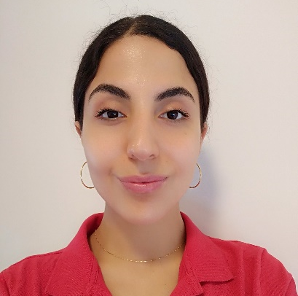
Mrs Madeline Ayoub is an environmentalist and has a Masters in Sustainability and Climate Policy. She is currently researching in the area of environmental sustainability for her PhD in terms of Education and pedagogical approaches. She has already had a paper published on sustainability and sustainable education.
Email: Madeline.ayoub@postgrad.curtin.edu.au

Relevant Links
Curtin Academy
Please follow the following link to find out more about Curtin Academy, the host and organiser of the program.
https://www.curtinacademy.com/

CA-I³SP Website
You can find a summary of the New Colombo Plan at the following link:
https://www.curtinacademy.com/newcolumboplan
Please use the link below to access the program’s website which includes a traveller’s portal on the connect page with further information about your travel with links to questions and answers boards, and itinerary guides available.
https://ca-i3sp.weebly.com/

Social Media
Instagram: n_c_p_2022
Facebook: Curtin Academy NCP

QR Code
Please use the following QR Code to ask questions about the program, activities, and other information.

